Title: Network Traffic Analysis – Xaltius Academy Cybersecurity Certification Project
Name: Adeseye Nelson Olaiyapo
Date: 28/02/2026
Course Instructor: Mr Eduardo
Link:https://drive.google.com/open?id=1gM8EDj8dlY3dOD7jEx2YT8azY9UnxTmv&usp=drive_fs
1. Introduction
- Purpose:
This report documents a digital forensics investigation of a captured network traffic file during a major cyberattack in our organisation. The goal is to identify key evidence, including the target machine, FTP credentials(username), executable file uploaded by attacker using the FTP service, administrator password, and a hidden “secret” message.
- Scope:
Tools used: Wireshark, Steghide, John the Ripper, CrackStation, zsteg etc.
2. Methodology
- 2.1 Tools
- Wireshark: For protocol analysis, conversation analysis, and stream reconstruction, file extraction using export objects feature.
- Steganography tools: Steghide/OpenStego for hidden data extraction.
- Password cracking tools: John/hashcat for cracking any recovered hashes.
- 2.2 Workflow
- Step 1: Opened PCAP and identify main hosts and protocols.
- Step 2: Focused on FTP and HTTP traffic for credentials and file transfers.
- Step 3: Extracted transferred files and web objects.
- Step 4: Perform steganography analysis on suspicious images.
- Step 5: Cracked any discovered hashes to recover passwords.
- Step 6: Correlated findings to answer the five questions.
3. Findings per question (step-by-step)
- 3.1 Question 1 – Target machine IP
- Question: “What is the IP address of the target machine?”
- Analysis steps:
- I opened the PCAP in Wireshark and navigated to Statistics → Conversations → IPv4 to identify the most active hosts. I also looked at protocols. I navigated to Statistics → Protocol Hierarchy
- I observed that IP 192.168.158.129 received the majority of FTP and HTTP connections.
- Using the filter ftp and http, http.request, ip.addr==192.168.158.129 && ip.addr==192.168.158.131. I finally used the 3 way handshake (SYN→SYN-ACK→ACK) I confirmed that the IP address of the target machine 192.168.158.131
- Evidence:
Screenshot of Conversations window.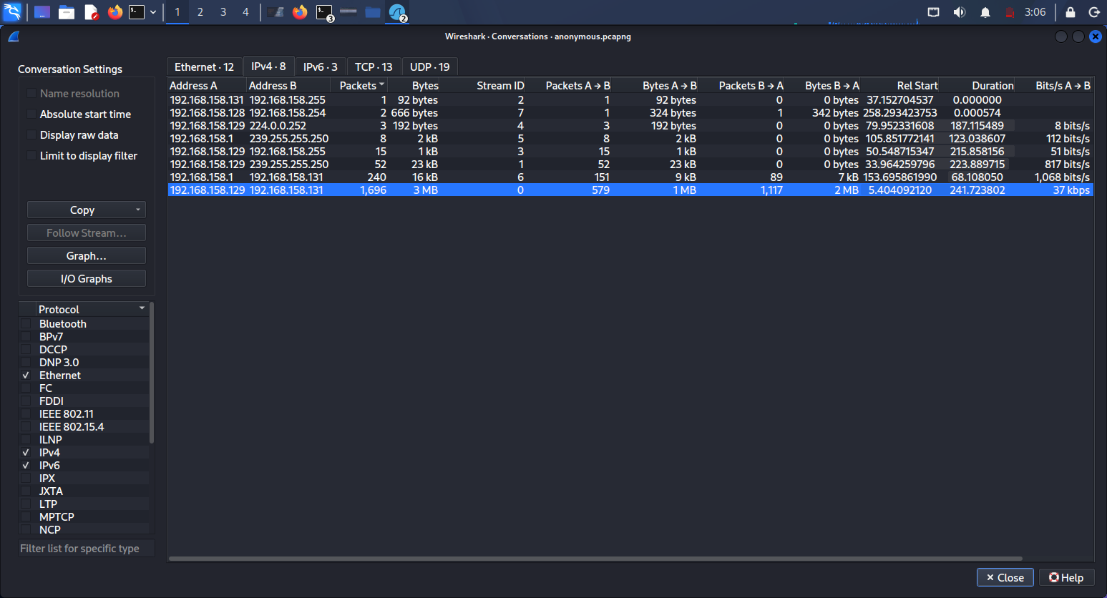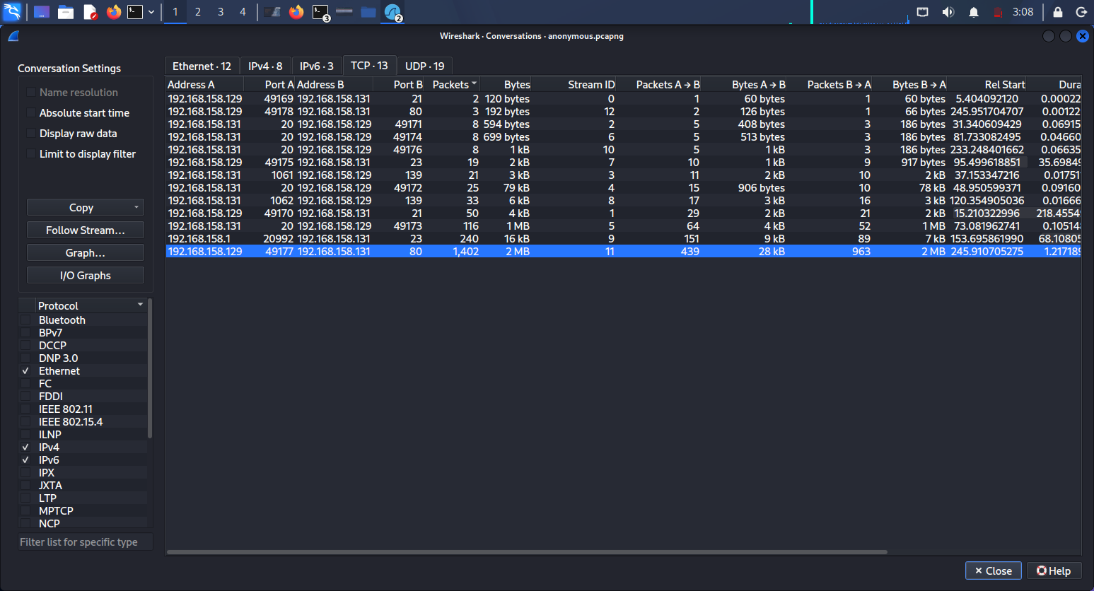

Screenshot of a relevant FTP/HTTP packet showing the destination IP.
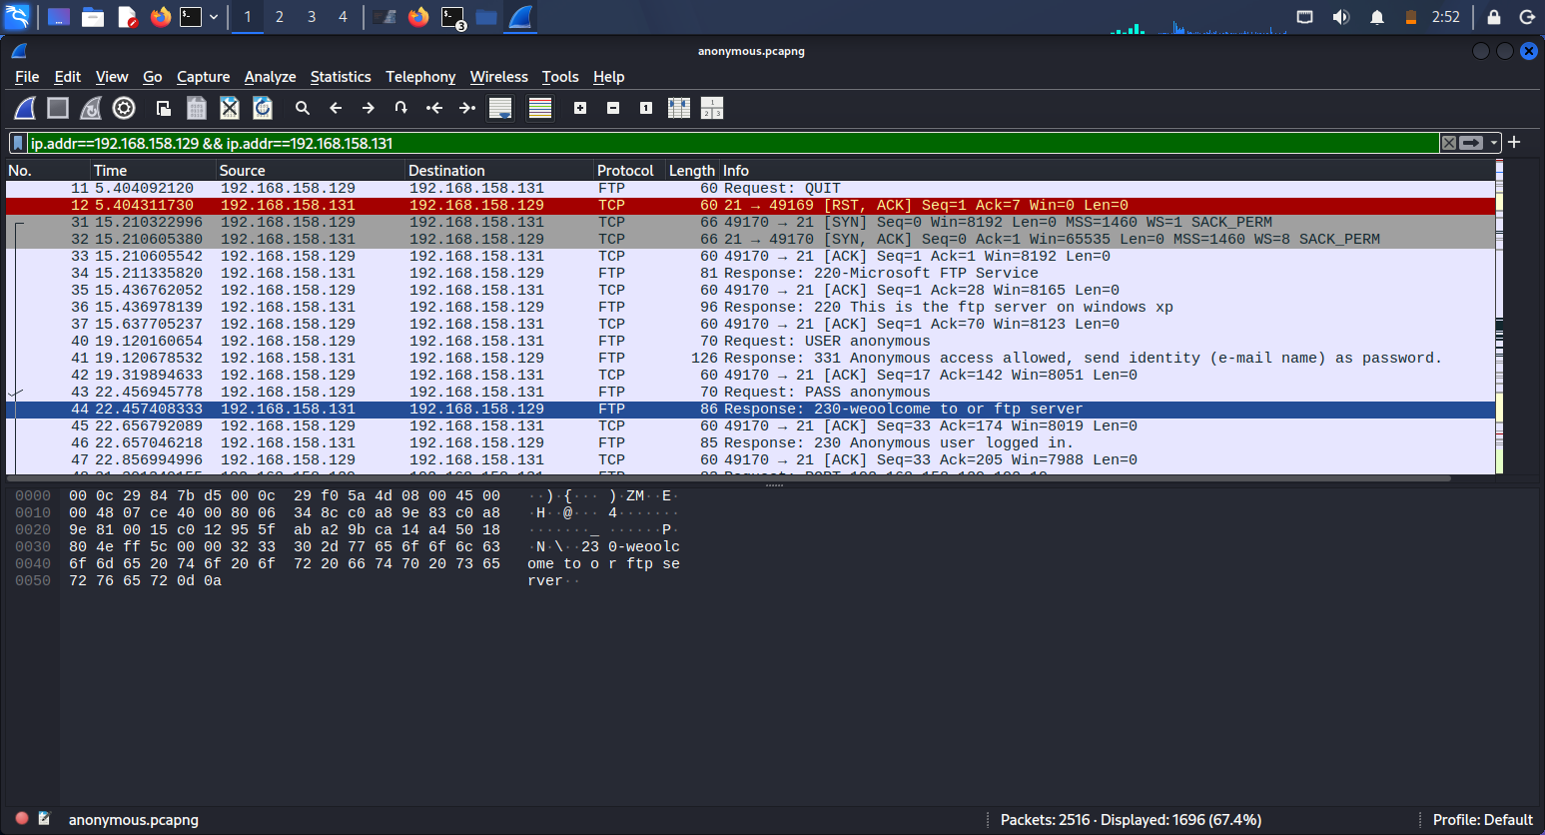
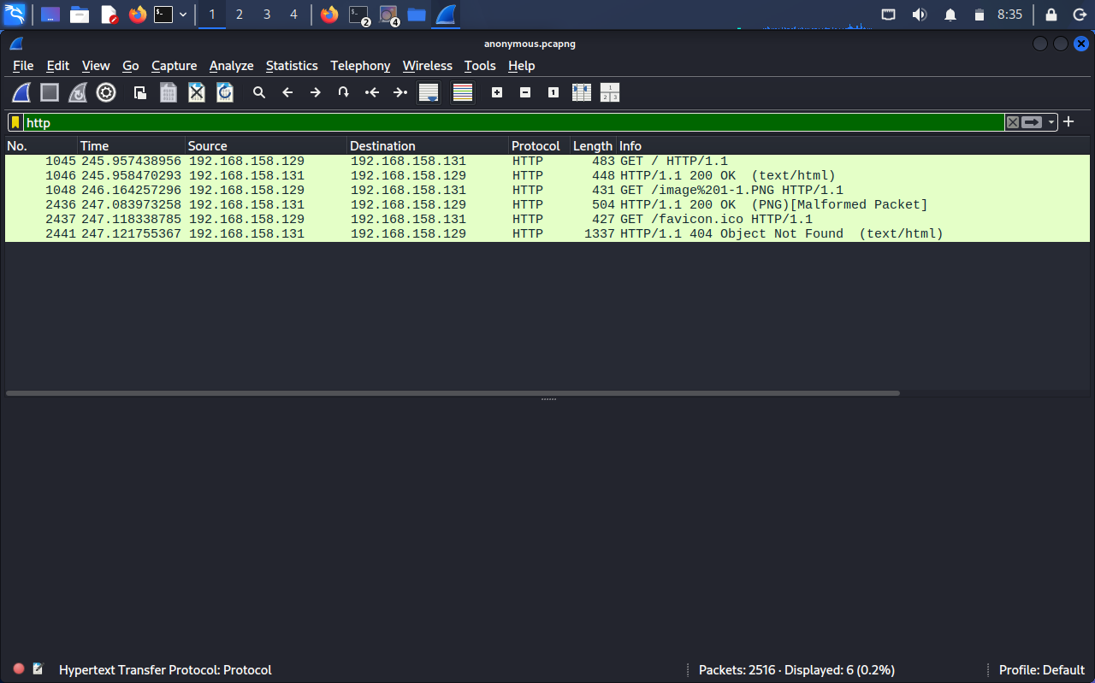

Screenshot Of 3 way handshake SYN, SYN-ACK, ACK
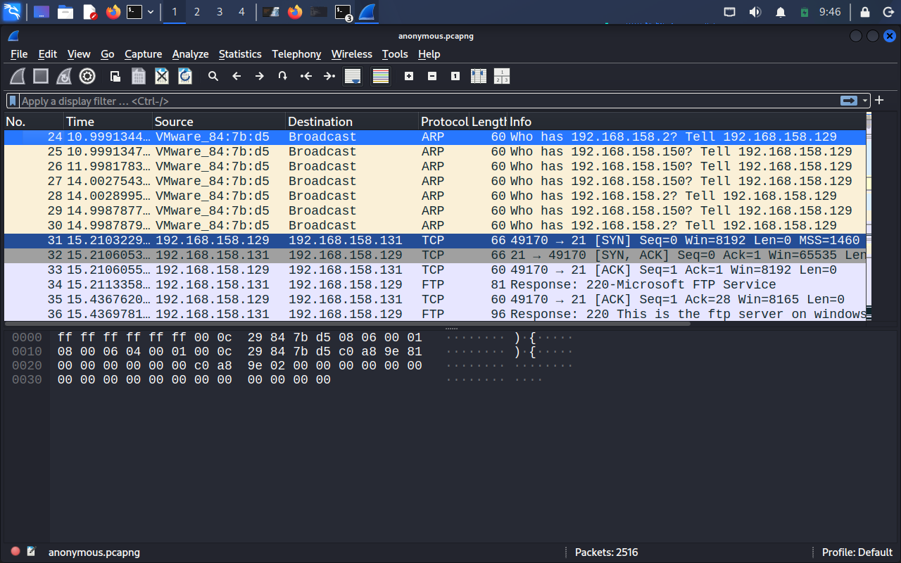
Answer: The target machine IP address is: 192.168.158.131
- 3.2 Question 2 – FTP username
- Question: What is the ftp username ?
- Analysis steps:
- I applied to the display filter ftp in Wireshark to isolate FTP control traffic.
- I followed the TCP stream of the FTP session I filtered, scroll to stream 1 and located the USER command or filter tcp because it happen in TCP protocol (syn, syn-ack, ack)
- Evidence:
Screenshot of the TCP stream showing USER <anonymous>.
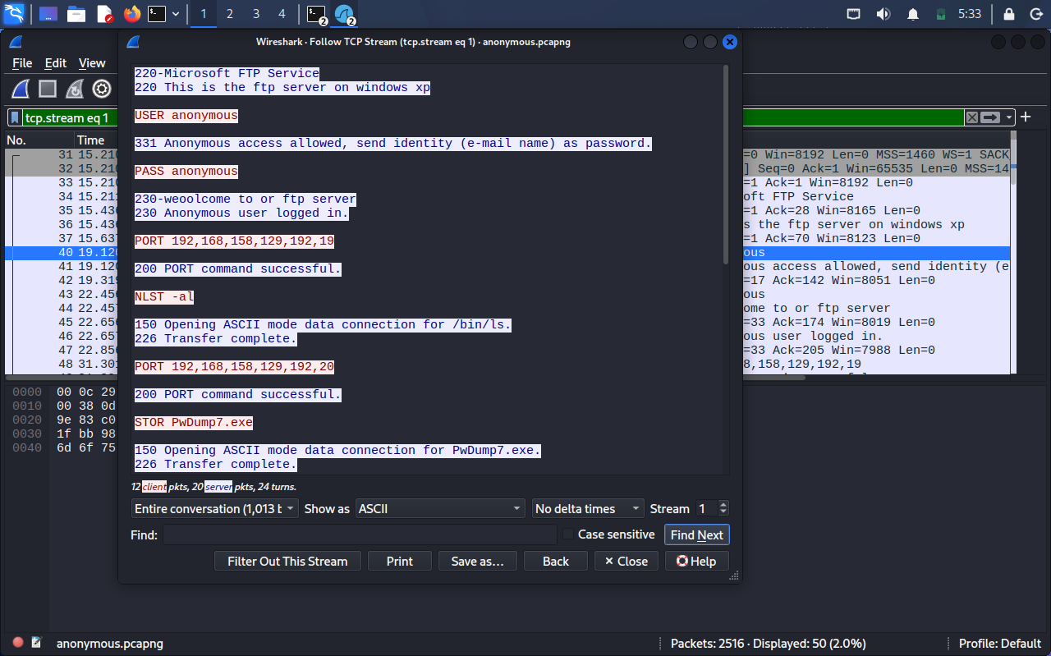
Answer: The FTP username is: anonymous.
- 3.3 Question 3 – Uploaded executable name
- Question: What is the name of the executable file uploaded by the attacker using the ftp service?
- Analysis steps:
- Within the same FTP stream, I searched for file upload commands such as STOR.
- I identified a command STOR <PwDump7.exe>, indicating the attacker uploaded this executable.
- Using File → Export Objects → FTP, I confirmed the file name and saved it locally.
- Evidence:

Screenshot of FTP stream showing STOR.
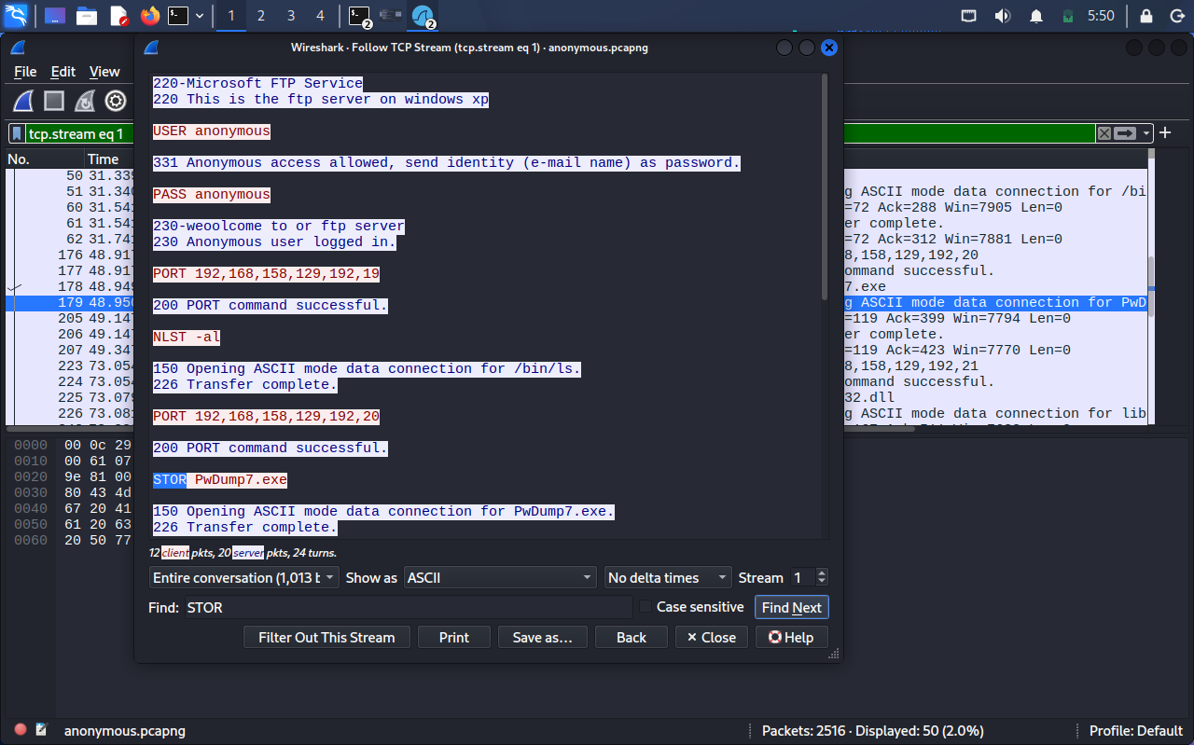
Screenshot of Export Objects window.
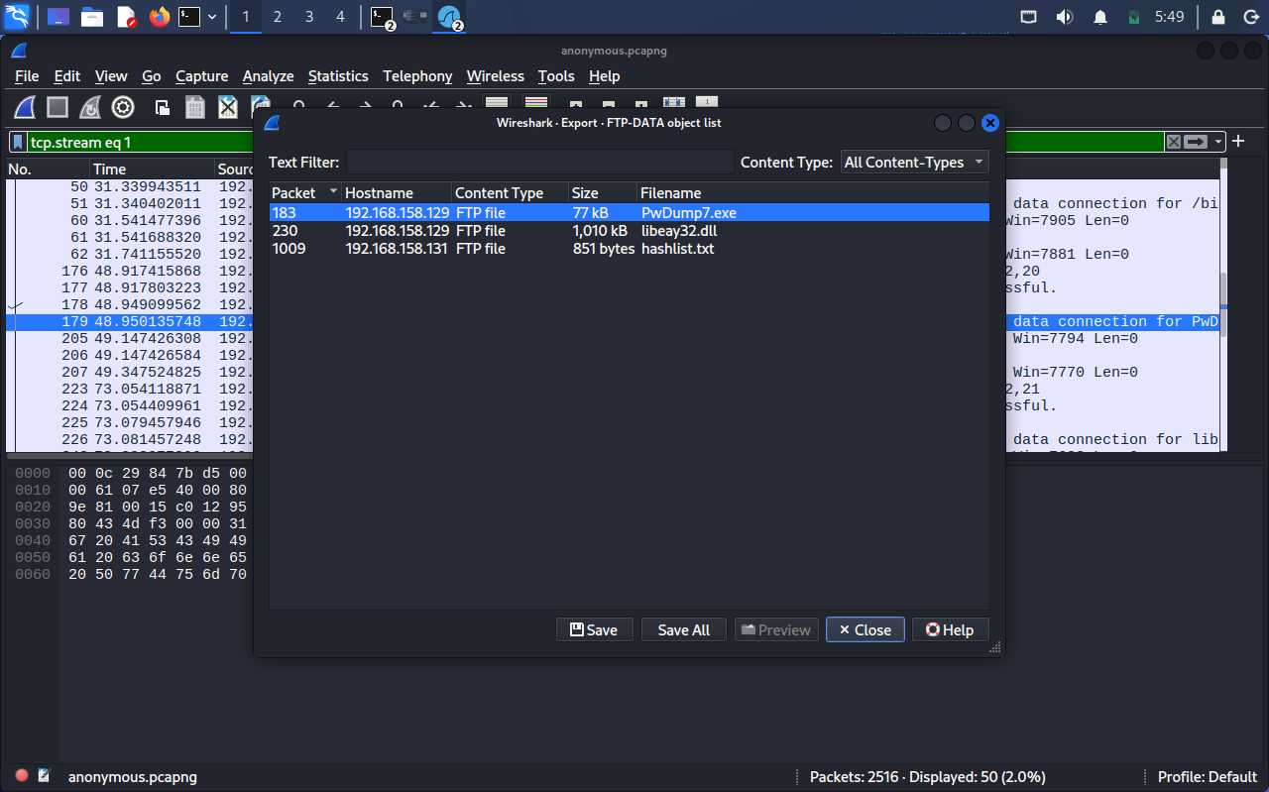
Answer: The executable uploaded by the attacker is: PwDump7.exe.
- 3.4 Question 4 – Administrator password
- Question: What is the administrator password?
- Analysis steps:
- I searched for credentials in FTP and HTTP traffic using filters ftp and http.
- I followed TCP streams on both FTP and HTTP filter and inspected GET requests for image.PNG
- I found mixed of hashes and clear-text in stream 10.
- I entered http or ftp on filter again, highlight/select the GET request
- Go to file→export objects→FTP-DATA. Here, the excutable file was displayed with a “TXT” file named hashlist.txt. I saved all files I found.
- The hashlist.txt was NTLM hash
- I created a file named hash.txt, copied and pasted only the NTLM(the administrator hash) in the file.
- I used John/hashcat with the command <john hashlist.txt --wordlist =/usr/share/wordlists/rockyou.txt --format=NT>, <john --show hash.txt>, and hashcat -m 1000 hash.txt /usr/share/wordlists/rockyou.txt or hashcat -m 1000 hashlist.txt /usr/share/wordlists/rockyou.txt --show
- I make use of rockyou wordlist to cracked it.
- I also used crackstation to cracked the hashes one after the other to confirm.
- Evidence:
Screenshot of the packet/stream where the password or hash appears.
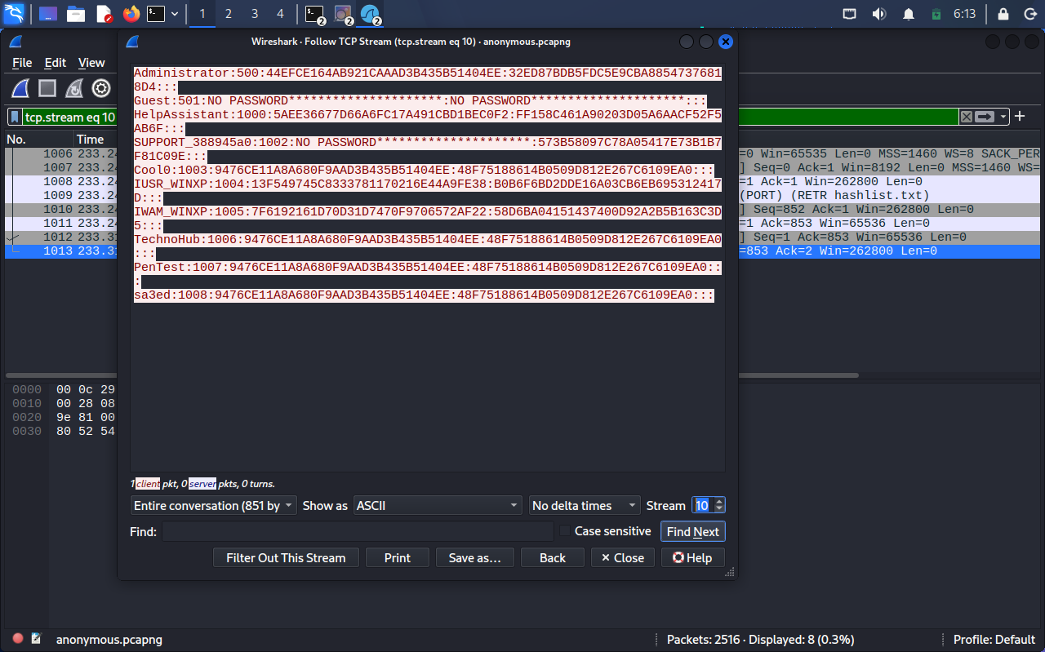
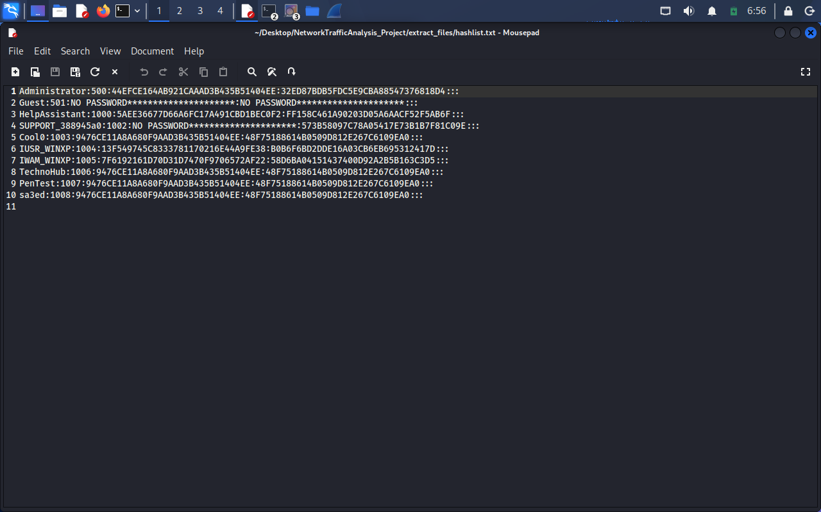

Screenshot of the cracked NTML hash using john
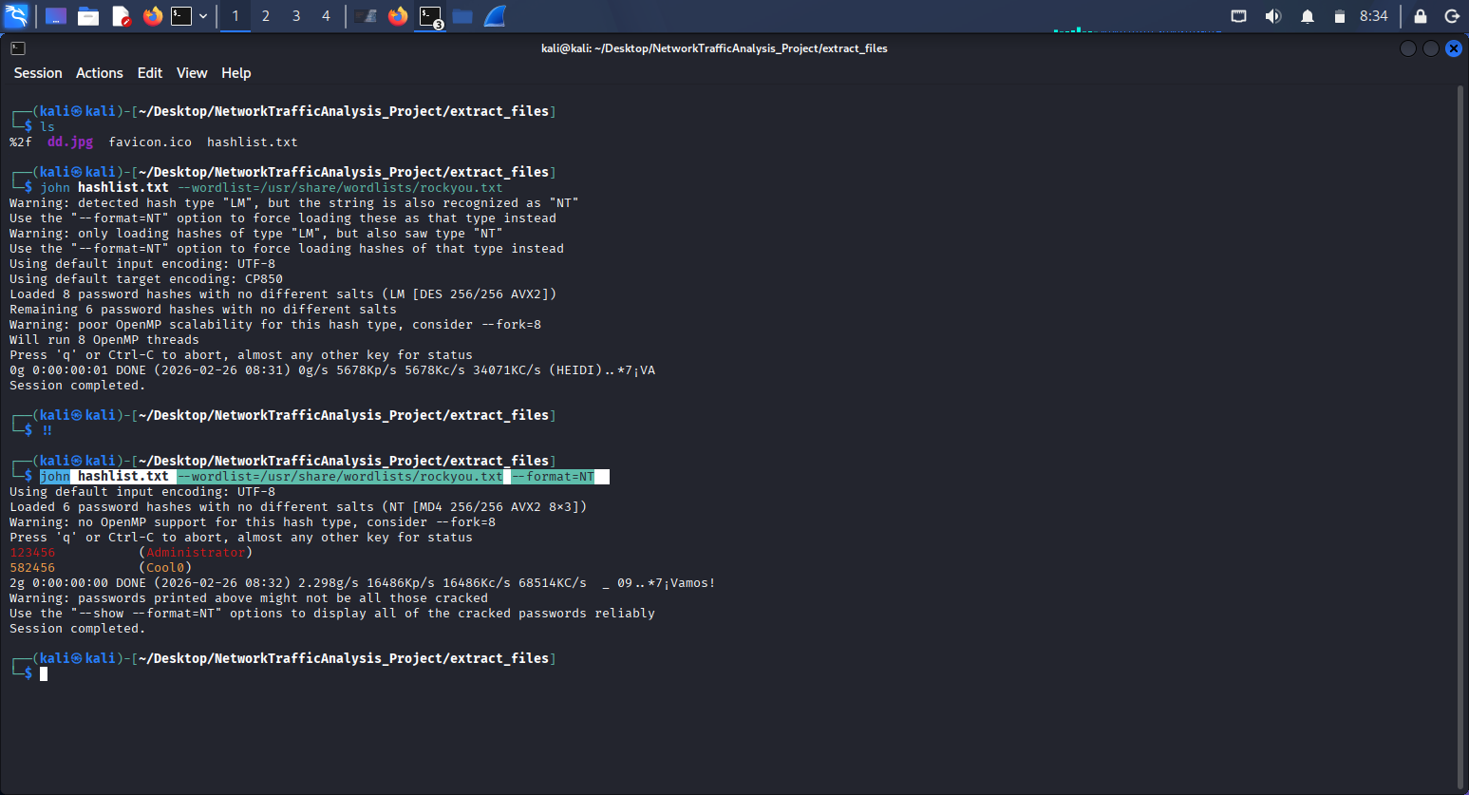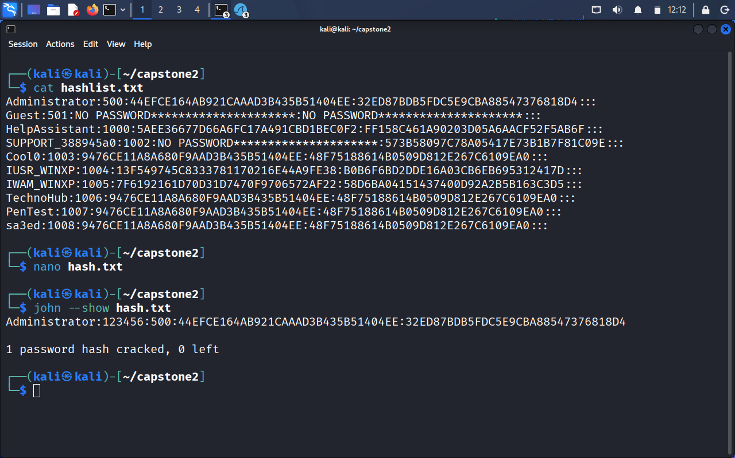

Screenshot of the the NT hash using hashcat
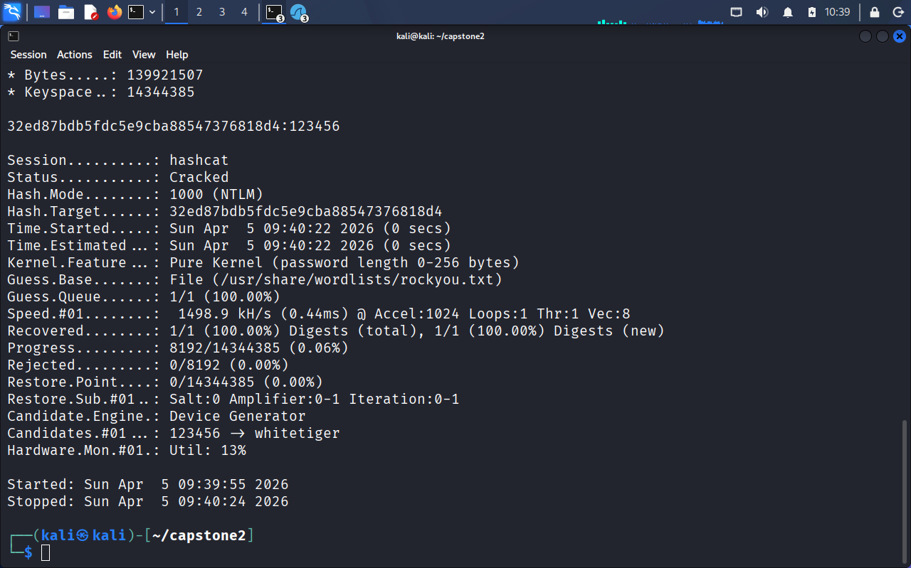
Screenshot of the NTML hash using crackstation
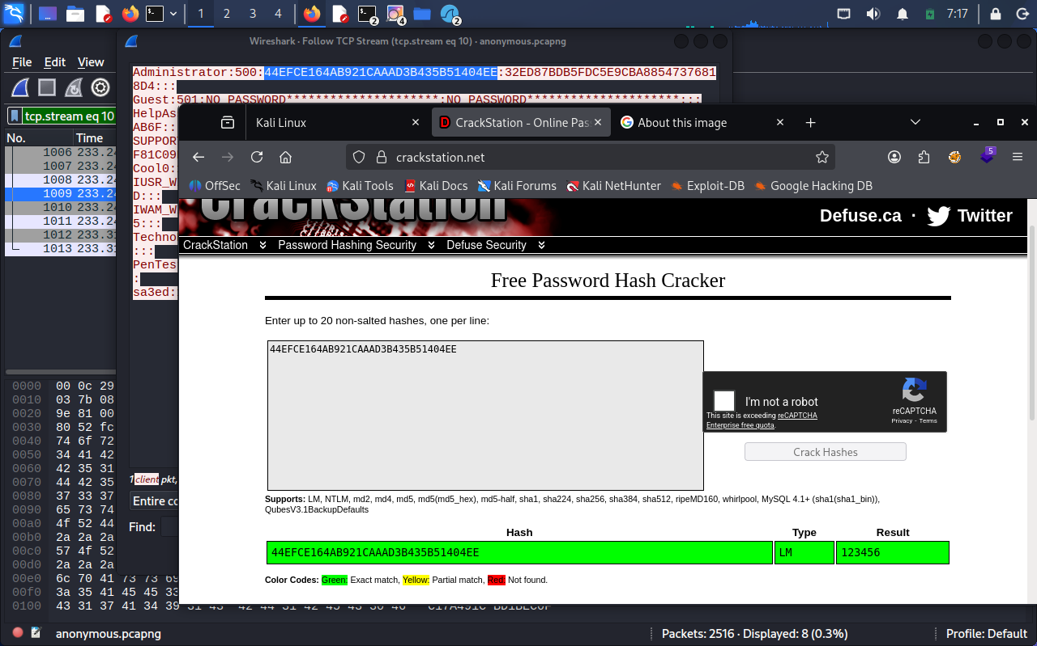
Answer: The administrator password is: 123456.
- 3.5 Question 5 – Hidden website “Secret” message
- Question: What is the website hidden "Secret" message?
- Analysis steps:
- I filtered HTTP to check http traffic
- To see the traffic, go to analyse→follow→HTTP Stream
- The GET request (in the http stream) against the target 192.168.158.131 shows that the attacker try to download the image201%1-1.PNG
- Go to File → Export Objects → HTTP to save web pages and images.
- I inspected the HTML source for hidden comments or encoded strings.
- I identified a suspicious image <image%201-1.PNG> referenced on the site.
- Feh image%201-1.PNG→Applied Steganography
- I also used exiftool to know the metadata.
- I discovered the word “trailer data” means there’s an hidden information behind the image.
- I installed zsteg to open the png image using this parameter zsteg -a dd.png. Note, dd.png= image%201-1.PNG.The tool successfully extracted a Hex code containing the secret message which is “open me if you can”
- Applied binwalk image%201-1.PNG on the image and observed a compressed RAR archive data
- Applied binwalk -e image%201-1.PNG to extract
- Typed cd _image%201-1.PNG.extracted
- I typed ls to list and check the extracted file which is a rar file
- I utilized unrar to opened the file, using this parameter “unrar e 39438.rar
- A message popped up “Enter password (will not be echoed) for .Open_Me_If_You_Can.txt:”
- The rar file is not in the correct format for john the ripper to crack. I utilized rar2john to transform the rar file into a format that john the ripper understand
- In ( _image%201-1.PNG.extracted directory) Typed rar2john 39438.rar > hashrar
- Typed ls
- Typed cat hashrar
- The format used by john is rar5
- Typed john --list=formats | grep ‘rar’ to check if john the ripper support rar5
- Typed john hashrar --wordlist=/usr/share/wordlists/rockyou.txt --format=rar5
- Typed cd _image%201-1.PNG.extracted
- Typed unrar e 39438.rar
- cat .Open_Me_If_You_Can.txt
- The hidden message is “Hidden_st3g”
• Evidence:

Screenshot of the image reference.
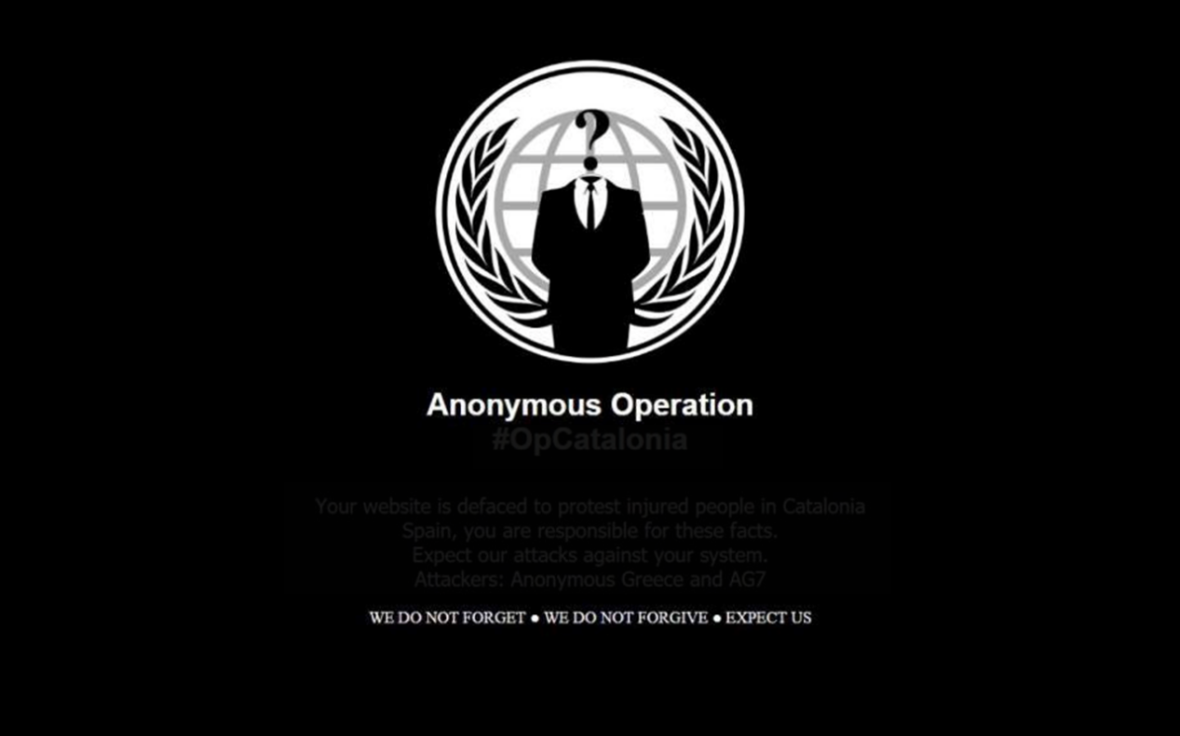
Screenshot/terminal output of zsteg extraction.
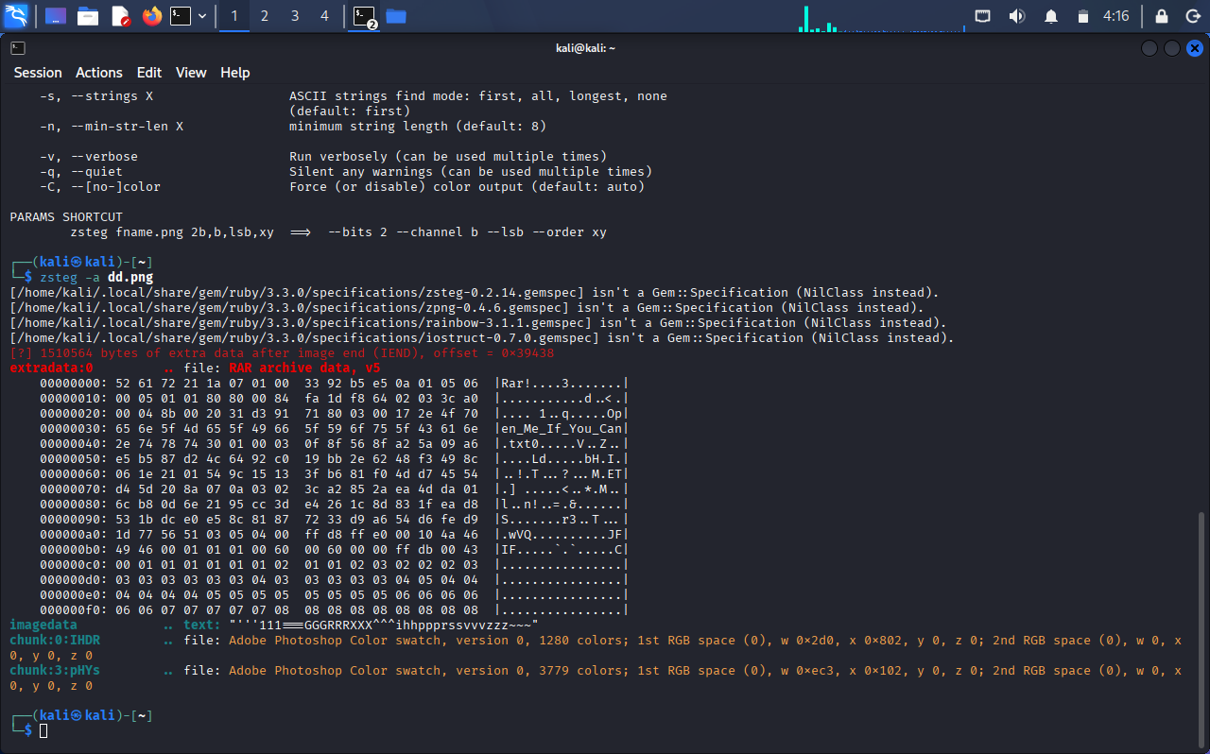

Screenshot of the brute force rar file password
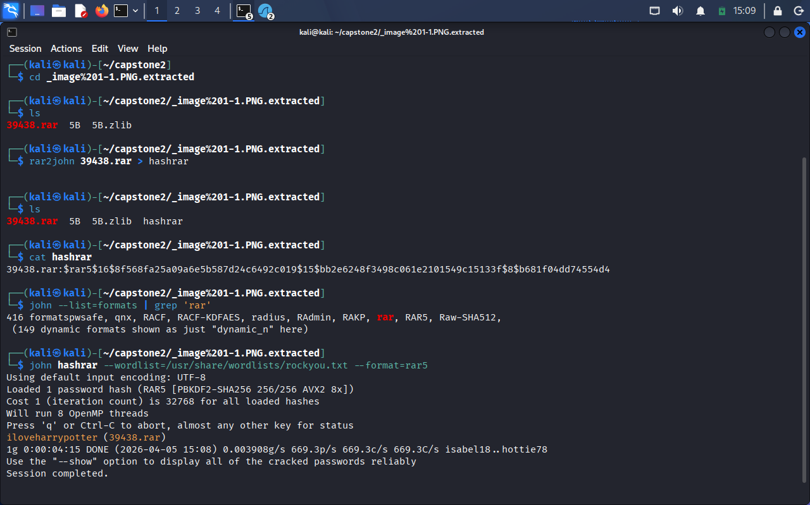
Screenshot of the hidden message
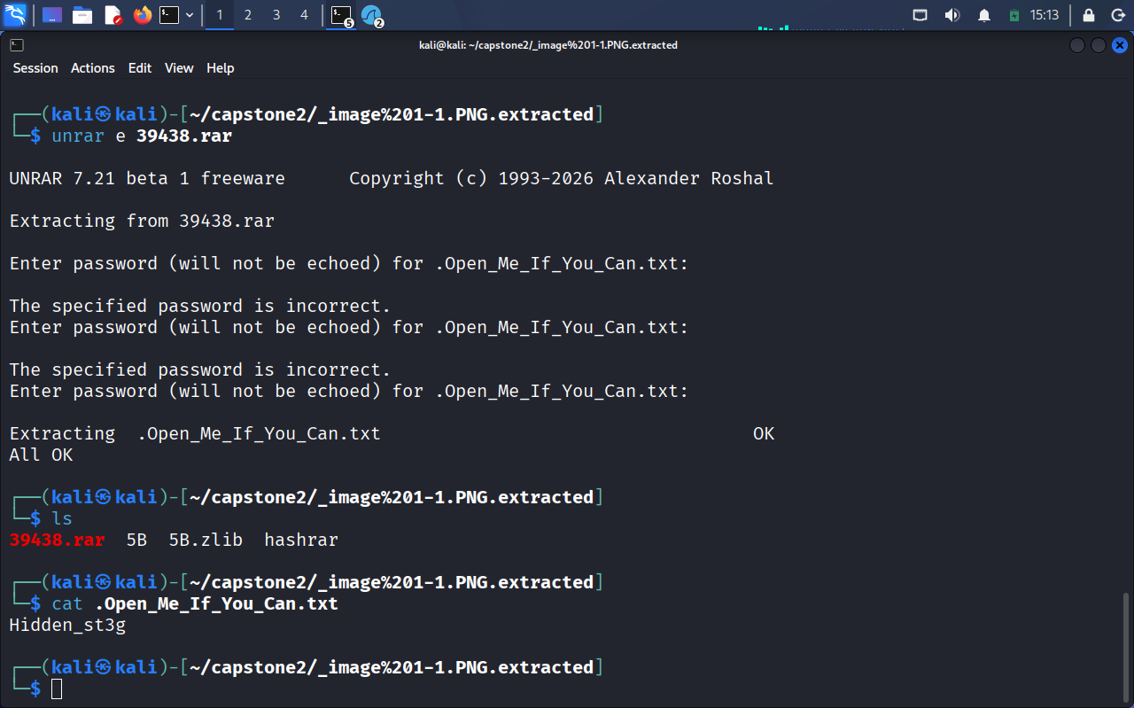
Answer: The hidden ‘Secret’ message is: <Hidden_st3g >.”
- 4.0 Conclusion
Summary of findings:
The analysis identified the target machine (192.168.158.131), the FTP username (<anonymous>), the uploaded executable (< PwDump7.exe.>), the administrator password (<123456>), and the hidden website message (<Hidden_st3g >).
- Recommendations:
- Enforce encrypted protocols (SFTP/FTPS, HTTPS) to prevent credential leakage.
- Implement network monitoring and alerting for unusual FTP uploads.
- Regularly audit web content and file integrity to detect hidden or malicious data.

